STANDARD TWINNING PROJECT FICHE
Strengthening the capacities of police administration

1. Basic Information
1.1 Programme: IPA 2009 component 1
1.2 Twinning Number: MN09/IB/JH/01
1.3 Title: Strengthening the capacities of police administration
1.4 Sector: 01.24
1.5 Beneficiary country: MONTENEGRO

2. Objectives
2.1 Overall Objective(s):
Strengthening the consolidation of the rule of law through the reinforcement of the institutional capacity in accordance with the Stabilisation and Association process.
2.2 Project purpose:
Strengthening the police administration capacities to combat organized crime and corruption, as well as implementing the Strategy for Integrated Border Management (IBM).

2.3 Contribution to National Development Plan/Cooperation agreement/Association Agreement/Action Plan

All strategic programming documents highlight the need to strengthen the efficiency of the police capacities to fully play its role as a guarantor of the rule of law.
The European Partnership was adopted following the independence of Montenegro in June 2006. The EP stresses the need to strengthen police capacities. The priorities of EP indicated the need to reinforce existing police capacities in the fight against organized crime.
The Stabilisation and Association Agreement (SAA) states under art 80 that in their co-operation on justice, freedom and security, the Parties shall attach particular importance to the consolidation of the rule of law, law enforcement.

The National Programme for Integration (May 2008-2012) stipulates that at the organizational unit’s regional level, the Department for organized crime and corruption shall appoint officers who will be responsible to deal with the issues of organized crime..

The Innovated Action Plan for implementation of the Programme for fight against organized crime and corruption (2008-2009) stipulates the need for defining working posts in the Regional Units for fight against organized crime and corruption. It also focuses on need to strengthen police capacities for the fight against organized crime. According to Innovated Action Plan for implementation of the Program for fight against organized crime and corruption it is stipulated to improve material preconditions for proper functioning of the law enforcement agencies. (See Annex IV).

3. Description

3.1 Background and justification:
The Twinning Project is part of a set of several projects aiming at improving and elaborating procedures for obtaining of information on organized crime, improving border controls, the detection of individual forms of organized crime, of the Forensic Centre technical equipment, of the international police co-operation, fight against the drug trafficking, corruption and organised crime.
The organisational structure of the Montenegrin police service changed as a result of the adoption of the Law on Police. The Law called for the separation of the Police Administration and the Ministry of Interior, and executive power over the police service now belongs to the Police Directorate. The reform of the police service is essential to enable the incorporation of modern aspects of policing such as transparency, accountability, a representative composition, respect and protection of human rights, and the notion of being a ‘service to the people’. Sustainable police reform not only requires the commitment of those inside the police service, but from all segments of society. Taking into consideration the importance of changes and necessity of reforms in all segments of police work, Police Administration, in accordance with the best police practices and standards, continues with reform processes by strengthening educational, operative, operative-technical and tactical capacities.

In regards to the Police Directorate it has been assessed that further development of criminal intelligence capacities and equipment is needed. Following the drafting of the new amended Rulebook on internal organisation of Police the capacities of the Department for fight against organized crime and corruption will be strengthened by creation of eight teams at the Regional Units level.
The Government’s strategy on IBM was adopted in February 2006 and an action plan for its implementation was adopted in December 2006. In relation to the existing physical facilities constructed with the international community's assistance there is still a need for further development of international border crossing points (BCPs). Current deficiency directly inhibits the introduction and implementation of effective and efficient border control procedures. The fact is that the border crossing points are in lack of IT equipment and it has poor communication links. Some border crossing points are not equipped with passport optical readers, license plate readers, lifesceen fingerprint reader, video surveillance and travel document examples database. When the above mentioned equipment is provided it is necessary to upgrade the national IT system (software) that will meet the IT European standards (Schengen Information System) on border crossing points. It is expected that national IT network will be advanced and it will support the process of information exchange between border crossing points, other organizational units of the Police Directorate and Interpol.
Under the Twinning Project the necessary training will be delivered through seminars and training for trainers. Concerning the equipment and its maintenance it is expected that the basic training will be provided by the supplier of the equipment. Part of the delivered equipment will be used for equipping the training simulation centre located at the Police Academy, Danilovgrad where training of police officers will be performed.

According to the Progress Report on Montenegro for 2008 issued by the European Commission modest progress has been made in the area of policing. The internal reorganization process has continued. Staff received extensive training, both general and specific, as along with English language lessons to facilitate international cooperation. However, the professional capacity of the police - particularly as regards use of modern investigation and analysis techniques - should be improved. Equipment and facilities, in particular for the organized crime department, need upgrading. The Progress Report also mentions that the Department for Fight against Organized Crime and Corruption has no staff at local level. Furthermore, "upgrading of professional skills is needed, especially with respect to modern investigation techniques, including financial investigations."
Having in mind that combating organized crime and corruption requires strong capacities of the police not only on central level but also on the spot, particularly in places where the risk of organized criminal activities and corruption is high, the government has planned the establishment of regional units of the Department for fighting Organised Crime and Corruption. In that regard the project will enable police officers from eight teams which will be created at the Regional Units level (Bar, Podgorica, Niksic, Bijelo Polje, Pljevlja, Berane, Herceg Novi, Budva,) to efficiently combat organized crime, corruption, trafficking in human beings, money laundering, smuggling of vehicles, commissioned murders, and international terrorism. Through trainings in Montenegro and study visits to the institutions dealing with similar topics within the EU Member States, the project will ensure transfer of know how in line with the EU standards.

In case certain related activities foreseen by the IPA 2007 project "Fight against organized crime and corruption" are fulfilled, the work plan of this project may be modified accordingly.

3.2 Linked activities (other international and national initiatives):
This project will take into consideration experiences gained during in the course of implementation of EU funded projects.
EU funded projects:
- Support to development of Integrated border management, IPA 2008 (2,450,000 EUR) – construction of access roads and parking lots for two BCPs.
- Fight against organized crime and corruption, IPA 2007, (3,000,000 EUR) – Twinning, supply of specialised equipment to the Criminal Police Department and construction of additional facilities for the Police Academy
- Construction of the border crossing point – Bozaj, CARDS 2006 (800,000 EUR) - completed
- Construction of the border crossing point -Debeli brijeg, CARDS 2004 (2,816,273 EUR) - completed.
- Construction of the border crossing point - Scepan polje, CARDS 2004 (1,141,444 EUR) - completed.
- EU donation (with USAID, IOM and OSCE) for border crossings equipment (500,000 EUR) - completed.

Other donor’s activities:

- Modernization and standardization of Forensic Centre Lab, intelligence-led policing activities in Montenegro (in cooperation with Swedish Assistance (SIDA)) focusing on two key areas of strengthening of criminal intelligence activities - implementation of an intelligence-led policing model and formation of a unified operations database and equipment.

- Community policing, with objective of improvement and encouragement of partnership between police and citizens as vital link in accomplishing positive security environment (successfully realized projects in Podgorica, Niksic and Ulcinj, in 2008 planned implementation of project on whole territory of Montenegro).

- Two projects submitted to the Netherlands Police by the Criminal Police Sector with the aim of providing external resources of financing for the area of the fight against drugs and terrorism.

- Project “Capacity Building of the Department for the Suppression of Commercial Crime” in collaboration with IOM (technical equipment procurement).
- Project for the procurement of equipment for activities of crime scene investigation and equipment for photo color processor (with Government of Norway).

- Project for equipment procurement and infrastructure for electronic data submission and managing and archiving of INTERPOL cases.

- In cooperation with the Police Directorate and UNODC (United Nation Office on Drugs and Crime) the project “Criminal Intelligence Analytics in the Criminal Police Sector” has been realized, and the sequel of this project is being prepared. This organization has also announced a donation in equipment: bullet proof vests, lap tops, radio-Motorola, and battery lamps for the end of month.

- The Police Directorate in cooperation with other public bodies participates in the project of OSCE called “Anticorruption Initiative in Montenegro” which started on 11 April 2008.

- Stability Pact- Interpol project. “National Plan for deployment of Interpol’s services in Montenegro”, 71,019 (for hardware) and (18,500 EUR for software). Project was realized in January 2008.

During the implementation stage of this Twinning Project it will be necessary to organise periodic meetings with other international donors.

3.3 Results:
The project will achieve the following results:
Result 1: Police administration capacities at regional level strengthened by establishing teams for fight against organized crime, conducting investigations and applying secret surveillance measures and financial analysis
Measurable indicators:
- Increased number of criminal cases investigated with modern investigation techniques
- Newly established teams in the regions capable of undertaking organised crime and corruption-related investigations independently and in cooperation with the Centre
- At least 100 police officers trained.
- Result 2: Technical and human resources developed to investigate organized crime by applying forensic techniques
Measurable indicators:
- Increased number of expert's reports on criminal acts with elements of organized crime and corruption.
- Increased number of identified criminals acts involving organized crime activities

- Result 3: Improved procedures and skills of staff for use of IT system at the border crossing points
Measurable indicators:
- At least 10 trained trainers
- Up to 100 trained users of IT system and Special operation procedures

The baseline for the relevant indicators will be specified later, but prior to the implementation of the project, in order to ensure adequate monitoring and evaluation of the project.

3.4 Activities:
Activity 1: Further development of the Department for fight against organized crime
1.1. Based on security assessment, conduct an analysis for the creation of up to eight teams within the Regional Units (Bar, Podgorica, Niksic, Bijelo Polje, Pljevlja, Berane, Herceg Novi, Budva,) to combat organized crime
1.2. Carrying out of training activities on combating organized crime, corruption, trafficking in human beings, money laundering, smuggling of vehicles, serious murders, and international terrorism for existing teams, including through conducting of financial investigations,
1.3. Carrying out of training activities and regional events for exchange of experiences on combating organized crime and corruption through regional approach (SEE)
1.4. Study visits to the institutions dealing with similar topics within the EU member states
1.5. Carrying out of training activities for using special investigation measures and secret surveillance measures
Activity 2: Further strengthening of the capacity to apply forensic techniques
2.1. Training of employees to use the forensic equipment.
2.2. Training of employees for DNA analysis on current inventory equipment
Activity 3 – Training on IT and Special Operational Procedures at BCPs
3.1. Preparation of a basic training manual on Special Operation Procedures.
3.2. Training for local trainers (gaining effective presentation skills), preparation of training module for the Police Academy
3.3. Training of end users on IT and special operational procedures

3.5 Means/ Input from the MS Partner Administration:

3.5.1 Profile and tasks of the Project Leader
The PL must have at least 10 years of relevant practical working experience and be a high-ranking official from a Member State (MS) law enforcement body with broad knowledge and practical experience in police work and police reform in EU, new Member States or Candidate Countries. The PL should have proven management skills and experience.
The PL will continue to work at his/her MS administration but devote some of his/her time to conceive, supervise and co-ordinate the overall thrust of the Twinning project and ensure the commitment of the MS Partner to the Twinning Project. The Project Leader should be able to lead an international team, have capacity to manage contacts with public institutions and build consensus at the highest level.
The PL will allocate a minimum of 3 days per month including one visit every 3 months to Montenegro as long as the project lasts.

3.5.2 Profile and tasks of the Resident Twinning Adviser (RTA) – 21 months

The RTA will be a senior police officer with at least 8 years of professional experience including experience in some of the areas covered by this assignment: criminal police with special reference to fight against organised crime, border policing, use of special investigation techniques.
  - University degree in law, police academy or other relevant field.
  - Excellent understanding of policing issues, including related EU standards and best practices
  - Excellent command of English, both spoken and written,
  - Excellent analytical, evaluation, management and planning skills,
  - Excellent communication skills in terms of interpersonal communications, mediation and report writing
  - Ability to adapt quickly to the local environment and understand constraints and opportunities of it
  - Experience in similar assignments in third countries (especially new EU Member States or Candidate Countries) will be an asset
  - Knowledge of local language will be an asset

Project Assistant - 20 months

The Project Assistant will assist the RTA in coordination and implementation of the activities and the exact profile will be decided at the point of the elaboration of the detailed work plan.

3.5.3 Profile and tasks of the short-term experts

Short-term experts (STEs) will cover the training and advisory activities. The STEs should have:
- relevant University degree
- minimum of 5 years professional experience in the respective field
- good written and oral command of English
- experience in training or advisory services.

4. Institutional Framework
The main Beneficiary of the project is the Police Directorate of Montenegro. The organizational structure of the Montenegrin police service changed as a result of the adoption of the Law on Police (see Annex IV). The Law called for the separation of the Police Administration from the Ministry of Interior, and the executive power over the police service now belongs to the Police Directorate.
Description of the Institutional framework
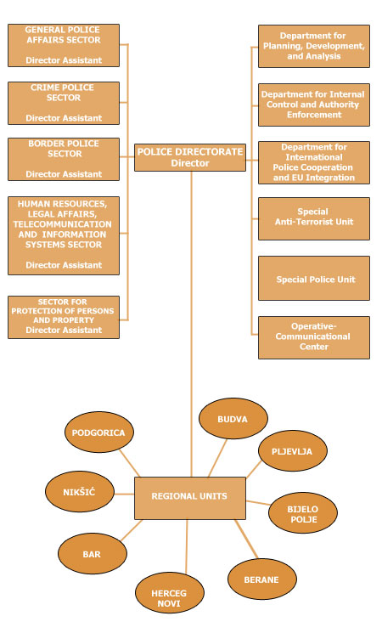

Organizational Scheme of the Criminal Police Sector
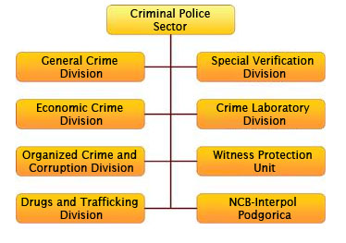

Organizational Scheme of the Border Police Sector
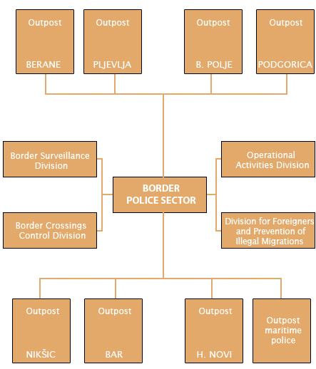

5. Budget
The budget allocated for this Twinning Contract is EUR 1,250,000.

6. Implementation Arrangements

6.1 Implementing Agency responsible for tendering, contracting and accounting
Mr Nicola Bertolini, Head of Operations
Delegation of the European Commission to Montenegro
Vuka Karadžića 12, 81 000 Podgorica, Montenegro
Telephone: +382 20 444 600
Fax: +382 20 444 666
Email: Nicola.BERTOLINI@ec.europa.eu.

6.2 Main counterpart in the BC,
Police Directorate
Svetog Petra Cetinjskog, 22
81000 Podgorica, Montenegro

Unit for fight against organized crime and corruption
Mr Rajko Malovic, Head of the unit
+382 67 284 588

IT Unit
Mrs Tatjana Drobnjak, Head of the unit
+382 20 241 833
E.mail- tatjanadrobnjak@cg.yu

Two project managers are nominated as the project's direct beneficiaries are two different sectors of the Police Directorate.

6.3 Contracts
One Twinning Contract

7. Implementation Schedule (indicative)

7.1 Launching of the call for proposals
October 2009

7.2 Start of project activities
Second quarter of 2010

7.3 Project completion
First quarter of 2012

7.4 Duration of the implementation period
21 months

8. Sustainability

The Montenegrin strategic framework for achieving progress in the area of fighting organised crime and corruption and the sustained commitment of the authorities is an important guarantee for the sustainability of the project results. Furthermore, the emphasis which the Programme for Fight against Organised Crime and Corruption and the related Action Plan as well as the strategic documents for IBM establishment put on strengthening the administrative capacity of the law enforcement bodies and particularly of the Police Directorate's Criminal Sector and Border Control Sector, ensures that also financing of these sectors from the national budget will be provided as a priority. EU assistance will be complementary to the national financing of the reforms.

The sustainability of this project's results will be ensured by the continuation of the reforms via already started or planned projects including the ones designed to establish and implement a national intelligence-led policing model as well as the ones aimed at fully equipping the BCPs with travel documents readers and linking all of the BCPs into a common network with a direct access to the Interpol database.
Training manuals elaborated under the Twinning Project will continue to be used by the Police Academy after the project's completion, in particular for the training of border police officers.

9. Crosscutting issues (equal opportunity, environment, etc…)

Equal opportunities for men and women will be secured through appropriate information and publicity material, in the design of projects and access to the opportunities they offer and through early monitoring of the composition of take up.
An appropriate gender balance will be sought on all the managing bodies of the project.
During capacity building activities and trainings through the twinning programme specific attention will be given to equal treatment and opportunities for women and the minorities.

10. Conditionality and sequencing

A key condition for the implementation of the Twinning project is that the Police Directorate remains committed to implementation of the Action plan of the Strategy for Integrated Border Management and Action Plan on fight against organized crime and corruption. Additional conditionalities include:
- Allocation of sufficient and stable financial, technical and human resources to the Police administration
- Commitment on behalf of senior level officials and experts of Police Directorate services involved in project implementation
- Adopted Rule-book on systematization of working posts (providing for human resources specialising in fighting organised crime in the regional police units).
- Availability of technical documentation at the disposal of staff.
- Qualified staff available and actively participating to the project activities.
- Available premises and infrastructure

A Steering Committee consisting of key stakeholders will be established for supervising the implementation of the Twinning Contract.

In terms of sequencing, it is planned that the Twinning Contract will be signed before the contract for supply for the Forensic Centre and Border Crossing Points in order to provide for the Twinning MS Partner assessing the provision of equipment and software and advising on the Technical Specifications for the supply.

The beneficiary must provide a written commitment regarding its co-financing obligation under the supply and service contracts related to the activities and objectives of the Twinning Contract.

ANNEXES
1. Logical framework matrix in standard format (see Project Fiche)
2. Detailed implementation chart (not provided)
3. Contracting and disbursement schedule by quarter for full duration of programme (including disbursement period) (not provided)
4. Reference to feasibility /pre-feasibility studies. For all investment projects, the executive summary of the economic and financial appraisals, and the environmental impact assessment should be attached (n/a)
5. List of relevant Laws and Regulations (see Project Fiche)
6. Reference to relevant Government Strategic plans and studies (may include Institution Development Plan, Business plans, Sector studies etc) (see Project Fiche)

