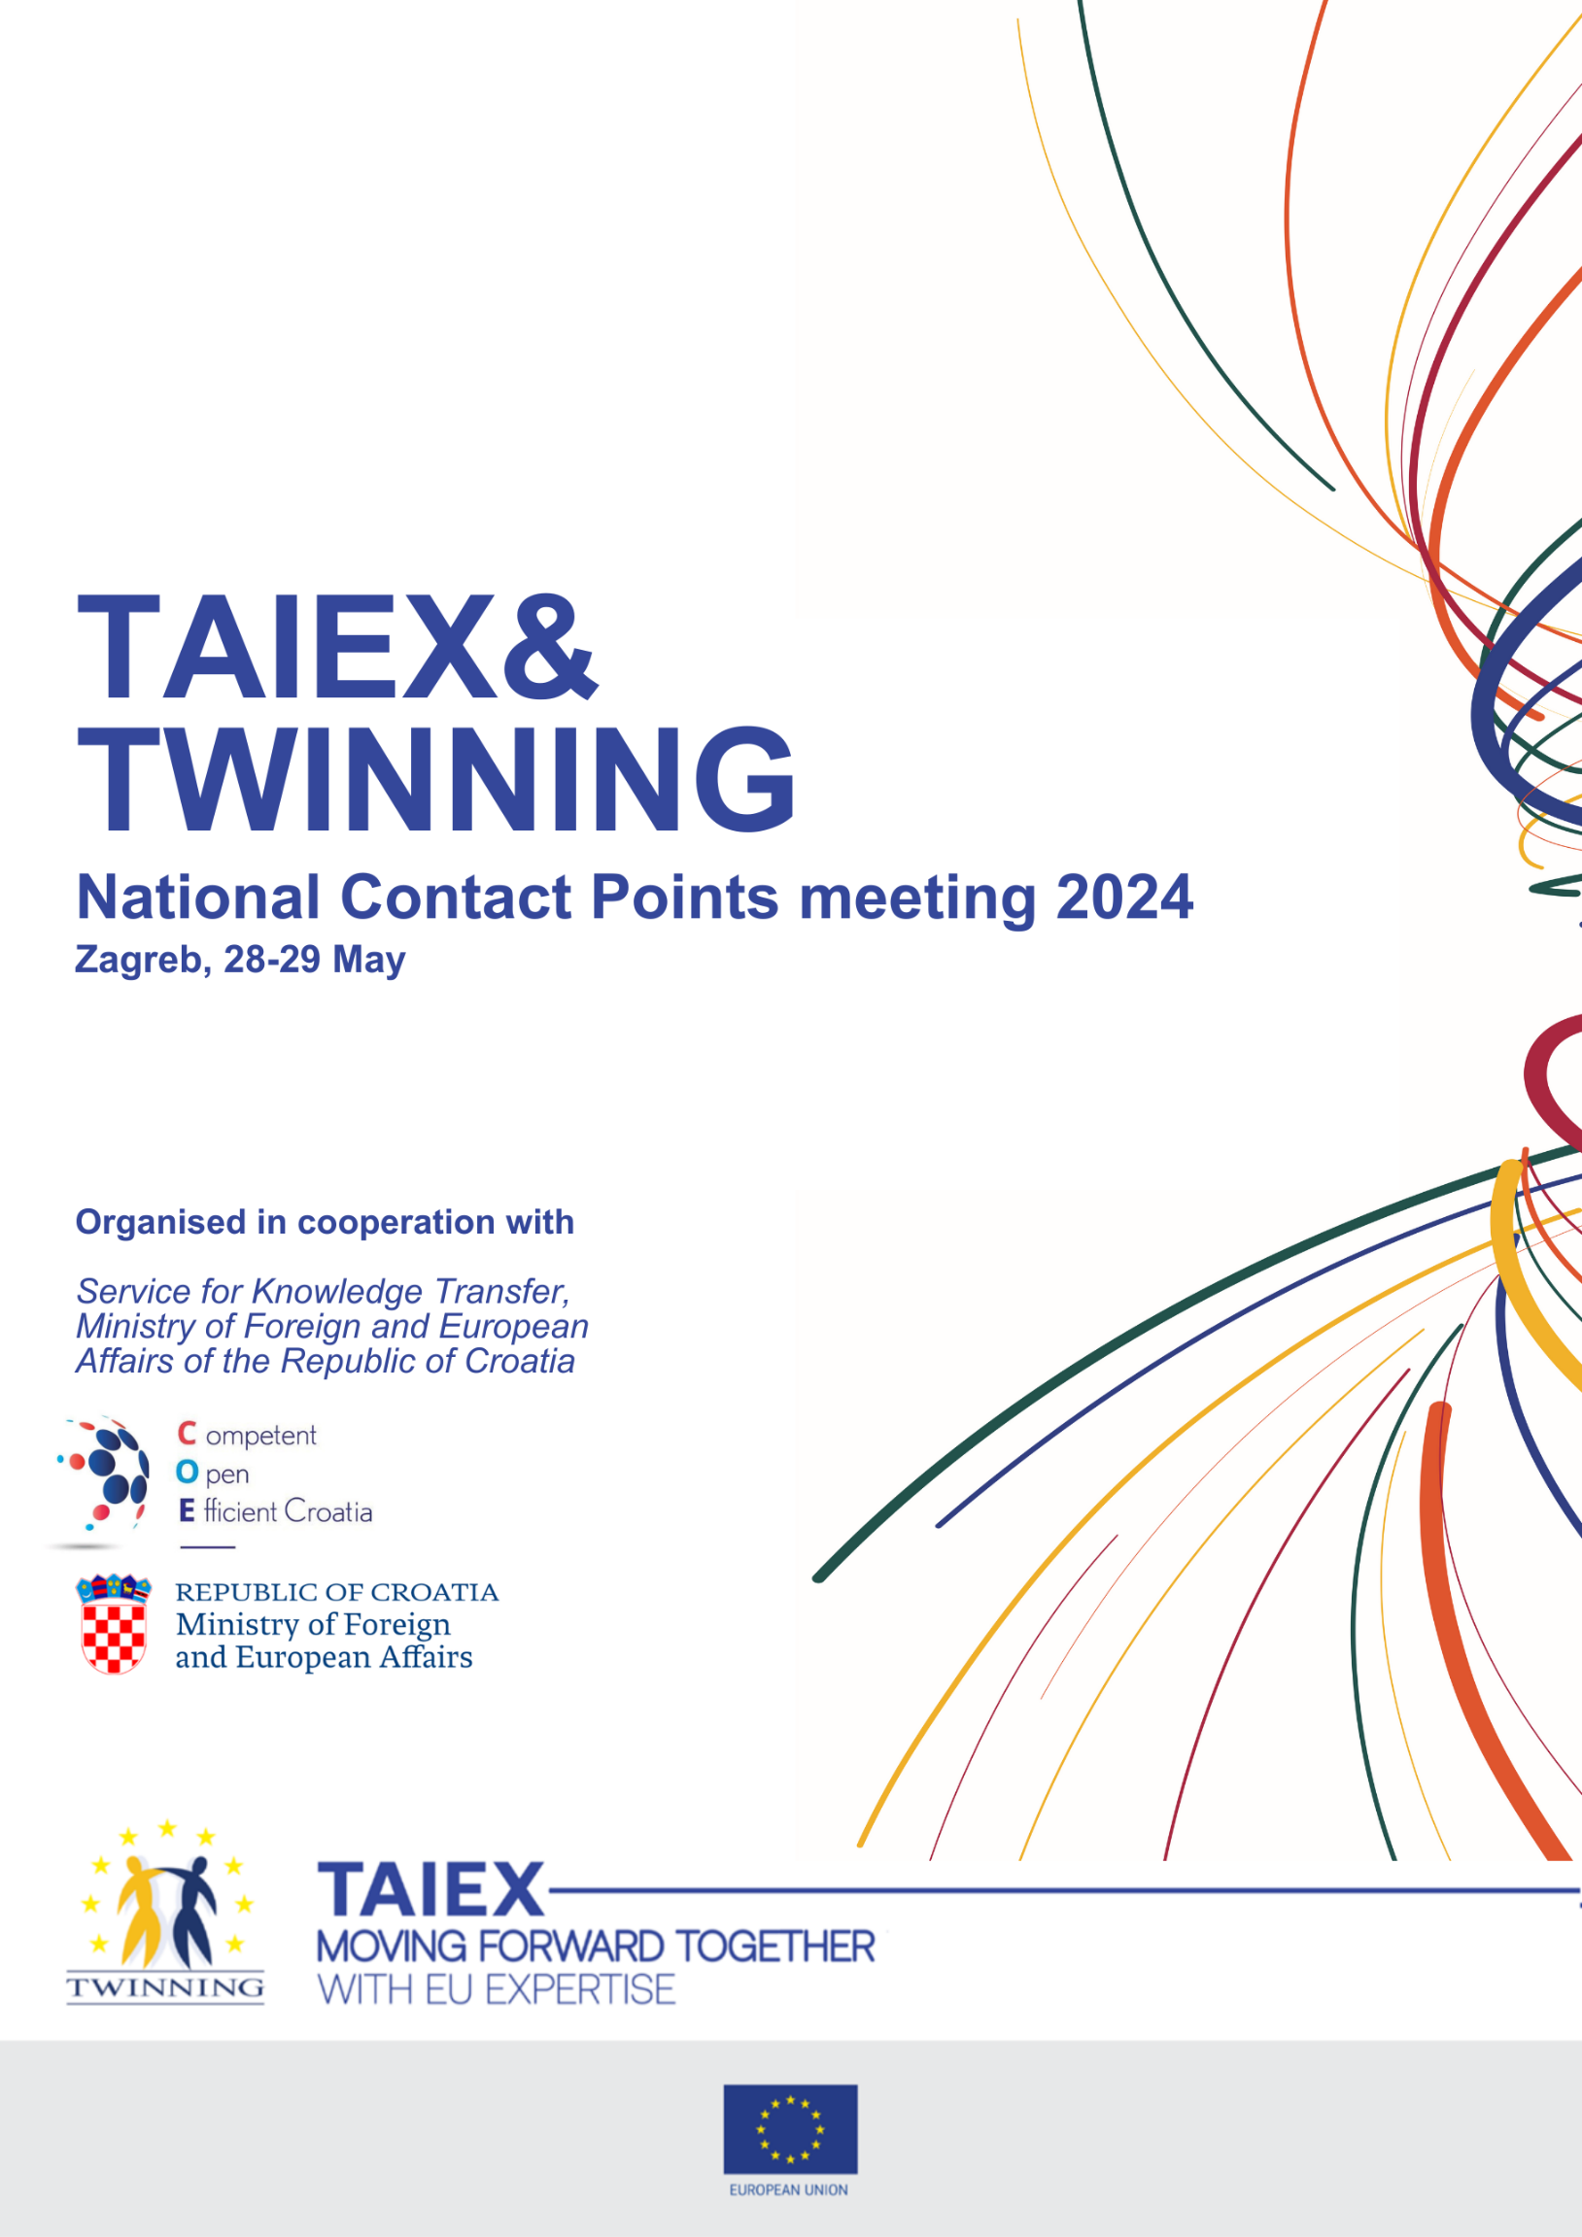

TAIEX & Twinning National Contact Points meeting 2024

Zagreb, 28-29 May

Day 1: Tuesday, 28 May 2024
From 08:30 | Registration and Welcome coffee, connecting participants
09:00 – 12:30 | Plenary session 1
9:00 – 9:30 | Welcome and introduction  Speakers:  Ms Gordana Vidović Mesarek, Director General European and International Law and Croatian NCP for TAIEX  Ms Adrienn Király, Director for Neighbourhood East and Institution Building, DG NEAR
9:30 – 10:00 | Overview of DG NEAR priorities and support of TAIEX and Twinning to DG NEAR priorities  Speakers:  Ms Adrienn Király, Director for Neighbourhood East and Institution Building, DG NEAR  Ms Sanna Silventoinen, National Contact Point for EU Twinning & TAIEX & TSI, Finland  Mr Janno Pajo, National Contact Point for Twinning and TAIEX, Estonia  Moderator: Ms Fanny Marchal, Head of Unit Institution Building, TAIEX & Twinning, DG NEAR
10:00 – 10:30 | Break
10:30 – 11:45 | Focus on Eastern Partnership countries – Looking ahead. Key priorities and working together.  Speakers:  Ms Adrienn Király, Director for Neighbourhood East and Institution Building, DG NEAR  Ms Astghik Hayrapetyan, National Contact Point for TAIEX & Twinning, Armenia  Speaker from Azerbaijan TBC  Mr Davit Bazerashvili, Head of EU Assistance Coordination and PAO, Georgia  Ms Emilia Cebotari, National Contact Point for TAIEX and Twinning, Moldova  Ms Maryna Kanavets, Director of the Center for Adaptation of the Civil Service to the Standards of the European Union, Ukraine  Ms Agnė Skaistytė, National Contact Point for Twinning and TAIEX, Lithuania  Mr Wojciech Gołębiowski, Counsellor-General/ National Contact Point for Twinning and Taiex, Poland  Moderator: Mr Pearce Quinn, Team Leader Unit Institution Building, TAIEX & Twinning, DG NEAR
11:45 – 12:30 | Croatia’s experience with the Twinning and TAIEX instruments  Speakers:  Ms Sanja Zekušić, Senior Advisor, Office of the Director General, State Geodetic Administration (experience from Twinning projects)  Mr Zvonko Širić, Head of Service for Audit of European Territorial Cooperation Programmes, Agency for Audit of European Union Programmes Implementation System (experience from Twinning projects)  Ms Višnja Grgasović, Head of Department Climate Policy Sector, Ministry of Economy and Sustainable Development (experience from TAIEX projects)  Ms Martina Librenjak, Head of International Regulations and Cooperation Department, Croatian Financial Services Supervisory Agency (experience from TAIEX projects)  Mr Marko Dragaš, Head of Department for Regional & Infrastructure Projects, Montenegro  Ms Elizabeta Buova, Head of Secretariat for European Affairs training center, TAIEX NCP, North Macedonia
12:30 – 14:00 | Lunch break at the hotel restaurant
14:00 – 15:00 | Breakout room 1: Focus on Southern Neighbourhood - Looking ahead. Key priorities and working together.  Speakers:  Introduction by DG NEAR  Dr Samar Al-Ahdal, National Contact Point for Twinning and TAIEX, Egypt  Ms Areej Alhadeed, National Contact Point for Twinning and TAIEX, Jordan  Ms Lamia Chamas, National Contact Point for Twinning and TAIEX, Lebanon  Mr Ahmed Al Muzaffar Al Ashhab, National Contact Point for Twinning and TAIEX, Libya  Mr Oussama Chellaf, National Contact Point for Twinning and TAIEX, Morocco  Ms Aglaé le Roux, National Contact Point for Twinning and TAIEX, France  Moderator: Mr Gregory Tsouris, Team Leader Institution Building Unit, TAIEX & Twinning, DG NEAR | Breakout room 2: Twinning technical update Part 1  Moderators:  - Pearse Quinn, Twinning Team Leader, Institution Building, TAIEX & Twinning Unit, DG NEAR  - Marija Price-Martic, Twinning Project Officer, Institution Building, TAIEX & Twinning Unit, DG NEAR
15:00 – 15:30 | Coffee Break and Networking in front of the conference room
15:30 – 16:30 | Breakout room 1: Focus on Western Balkans - Looking ahead. Key priorities and working together.  Speakers:  Introduction by Ms Adrienn Király, Director for Neighbourhood East and Institution Building, DG NEAR  Mr Sonil Bilaj, Director of the Directorate for Administration of EU Financial Assistance, Albania  Ms Lejla Spahic, National Contact Point for Twinning and TAIEX, Bosnia and Herzegovina,  Ms Dora Krasniqi, National Contact Point for TAIEX, Kosovo*  Mr Marko Dragaš, National Contact Point for TAIEX, Montenegro  Ms Evgenija Serafimovska Kirkovski, National Contact Point for Twinning, North Macedonia  Ms Jelena Stevanov, National Contact Point for TAIEX, Serbia  Mr Norbert Schultes, Head of Division Institutional Partnerships, Germany  Mr Gianfranco Bergantino, National Contact Point for Twinning and TAIEX, Italy  Moderator: Ms Fanny Marchal, Head of Unit Institution Building, TAIEX & Twinning, DG NEAR | Breakout room 2: Twinning technical update Part 2  Moderators: same as for Part 1
16:30 – 16:45 | Coffee Break and Networking in front of the conference room - Optional Family Photo
16:45 – 17:30 | Breakout room 1: Key takeaways from TAIEX mobilisation the past years and niche areas where we expect to grow  Speakers:  Jovita Gudelyte, Team Leader Institution Building Unit, TAIEX & Twinning, DG NEAR  Moderator: Mr Gregory Tsouris, Team Leader Institution Building Unit, TAIEX & Twinning, DG NEAR | Breakout room 2: Twinning technical update Part 3  Moderators: as for Part 1
17:00 – 17:30 | End of Day 1
19:30-21:00 | Cocktail dinner in Wine Bar Bornstein (hosted by Croatian MFEA)

Day 2: Wednesday, 29 May 2024
From 09:00 | Welcome coffee in front of the conference rooms
09:30 – 12:30 | Plenary sessions
09:30 – 10:30 | Croatia led session on passing from beneficiary to experience sharing.  Ms Gordana Vidović Mesarek, Director-General for European and International Law and Croatian NCP for TAIEX, Ministry of Foreign and European Affairs  Ms Dubravka Smolić Vlaić, Head of Service for Knowledge Transfer and Croatian NCP for Twinning, Ministry of Foreign and European Affairs  Ms Vedrana Kuštek, Senior Analyst, Central Finance and Contracting Agency  Ms Ugnė Chmeliauskaitė, Deputy Head of Development Cooperation Division, Lithuania  Mr Wojciech Gołębiowski, Counsellor-General/ National Contact Point for Twinning and Taiex, Poland  Moderator: Ms Iva Jantolek, Minister Counsellor, Service for Knowledge Transfer, Ministry of Foreign and European Affairs
10:30-11:00 | Coffee break in front of the conference rooms
11:00 –12:00 | What it is like to be an NCP (training/experience sharing/showcasing best practices)  Speakers:  Ms Astghik Hayrapetyan, National Contact Point for TAIEX & Twinning, Armenia  Mr Gianfranco Bergantino, National Contact Point for Twinning and TAIEX, Italy  Ms Lamia Chamas, National Contact Point for Twinning and TAIEX, Lebanon  Moderator: Ms Fanny Marchal, Head of Unit Institution Building, TAIEX & Twinning, DG NEAR
12:00-12:30 | Wrap-up & Closing remarks
12:30 – 14:00 | Lunch at the hotel restaurant
14:00 – 17:00 | Group Photo at Zrinjevac Park  Nikola Subic Zrinski Square (meeting at the reception 14:00)  Field Visit (optional - meeting at the reception 15:00)

Working languages: Translation in EN and FR will be available in the Plenary and TAIEX breakout sessions. Twinning sessions will take place in EN.

*This designation is without prejudice to positions on status and is in line with UNSCR 1244/1999 and the ICJ Opinion on the Kosovo declaration of independence.

